

Medtronic

MuleSoft Platform Developer Playbook

v1.0

Document Control Information

|  |  |
| --- | --- |
| Document Identification |  |
| Document Name | MuleSoft Platform Developer Playbook |
| Project Name |  |
| Client | Medtronic |
| Document Author | Kishore Reddy Paluri |
| Document Contributors | MuleSoft Professional Services Team |
| Document Version | 1.0 |
| Document Status | Draft |
| Date Released |  |

Document Edit History

| Version | Date | Additions/Modifications | Prepared/Revised by |
| --- | --- | --- | --- |
| 1.0 | 26-May-2020 | Initial Version | Kishore Reddy Paluri |

Document Review/Approval History

| Date | Name | Organization/Title | Comments |
| --- | --- | --- | --- |
|  |  |  |  |
|  |  |  |  |
|  |  |  |  |

Table of Contents

1 Introduction 4

1.1 Scope of Document 4

2 Developer Environment Setup 5

2.1 Installation 5

2.1.1 Install Java 5

2.1.2 Install Maven 5

2.1.3 Install Anypoint Studio 6

2.1.4 Configure Studio for Maven and Java JDK 1.8 7

2.1.5 Configure Anypoint Platform Settings in Studio 7

2.1.6 Maven Settings File 10

3 Detailed Steps in exposing API in Mulesoft Platform 12

3.1 API Design Phase 12

3.1.1 Identify Use Case (business use-case) 13

3.1.2 Identify APIs, Resources 13

3.1.3 Create API Assets 14

3.1.4 Validate and Feedback 18

3.2 API/Service Build Phase 19

*3.2.1* Develop API/Service using the API Specs: 27

3.2.2 MUnit Testing 28

4 Secure the API 29

5 Automated Deployment 30

# Introduction

## Scope of Document

This document details the steps to set-up the developer environment, develop an api and implement the api life cycle.

# Developer Environment Setup

This section provides high level instructions for setting up a developer desktop/laptop to get started with Mule application development. Following are the software’s that are required:

1. Java JDK 1.8
2. Maven 3.6.x and above (Maven is packaged with Anypoint Studio)
3. Anypoint Studio (7.5.x and above with 4.3.0 runtime version).

|  |  |
| --- | --- |
| Components | Details |
| Hardware Requirements | 4GB of free memory available  2GHz CPU  10GB free hard drive space |
| Software Requirements | * Oracle JDK 1.8 * Maven 3.6 and above * Anypoint Studio |
| Operating Systems | MacOS 10.12.0  Windows (32- and 64-bit) Windows 7, Windows 8, Windows 10 |
| Browsers | Google Chrome  Internet Explorer |

## Installation

This section provides steps for installing the software.

### Install Java

Anypoint Studio requires JDK 1.8 (can be found at https://adoptopenjdk.net/).

* After installing Java you need to set the environment variable JAVA_HOME that points to the base directory for the java install (not the bin directory).
* Make sure the JDK bin directory is the first item in your PATH environment variable

### Install Maven

Latest Apache maven installation zip file can be downloaded from here: <http://maven.apache.org/download.cgi>.

To install on Windows:

1. Unzip the distribution archive.
2. Add the unpacked distribution's bin directory to your user *PATH* environment variable by opening up the system properties.
3. In the same dialog, make sure that JAVA_HOME exists in your user variables or in the system variables.
4. Open a *new* command prompt and run mvn -version to verify that it is correctly installed.

### Install Anypoint Studio

Download the Anypoint Studio(7.5.x version) installation zip file from the MuleSoft website

<https://www.mulesoft.com/platform/studio>

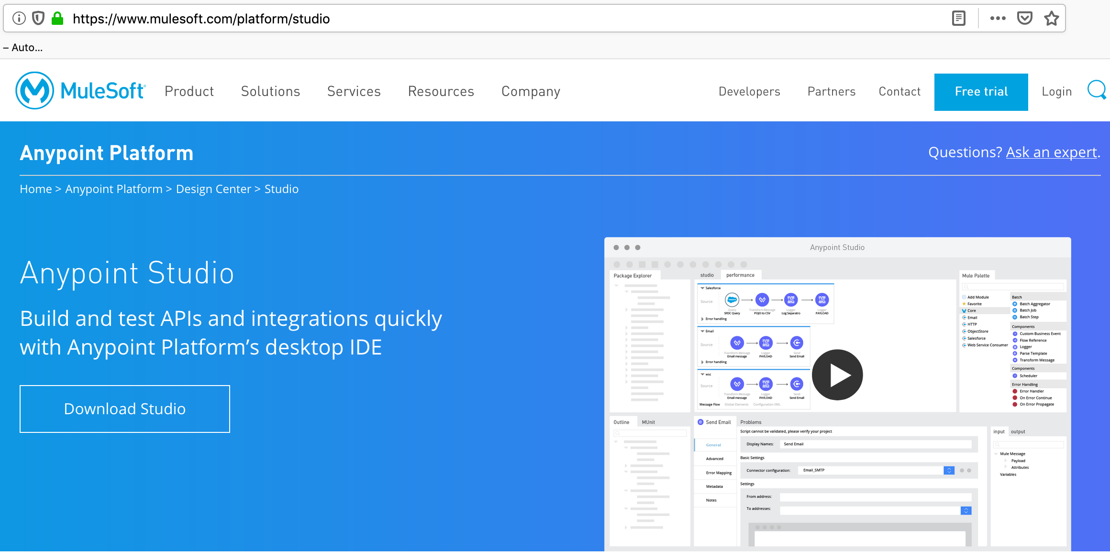

Note that detailed instructions are also available at that site.

<https://docs.mulesoft.com/studio/7.5/to-download-and-install-studio>

1. Download the version of Studio that is compatible with your operating system: Windows, Mac, or Linux.
2. Unzip the downloaded file to a directory on a hard drive located on your host machine. The Anypoint Studio folder or directory appears when the unzip operation completes.
3. Open Anypoint Studio by double-clicking the AnypointStudio.exe file, located in the Anypoint Studio directory

### Configure Studio for Maven and Java JDK 1.8

Open Anypoint Studio, from the Window --> Preferences --> Anypoint Studio menu, select “Maven” Settings and configure to use the embedded Maven as shown below (by default this will be enabled (but check it to confirm).

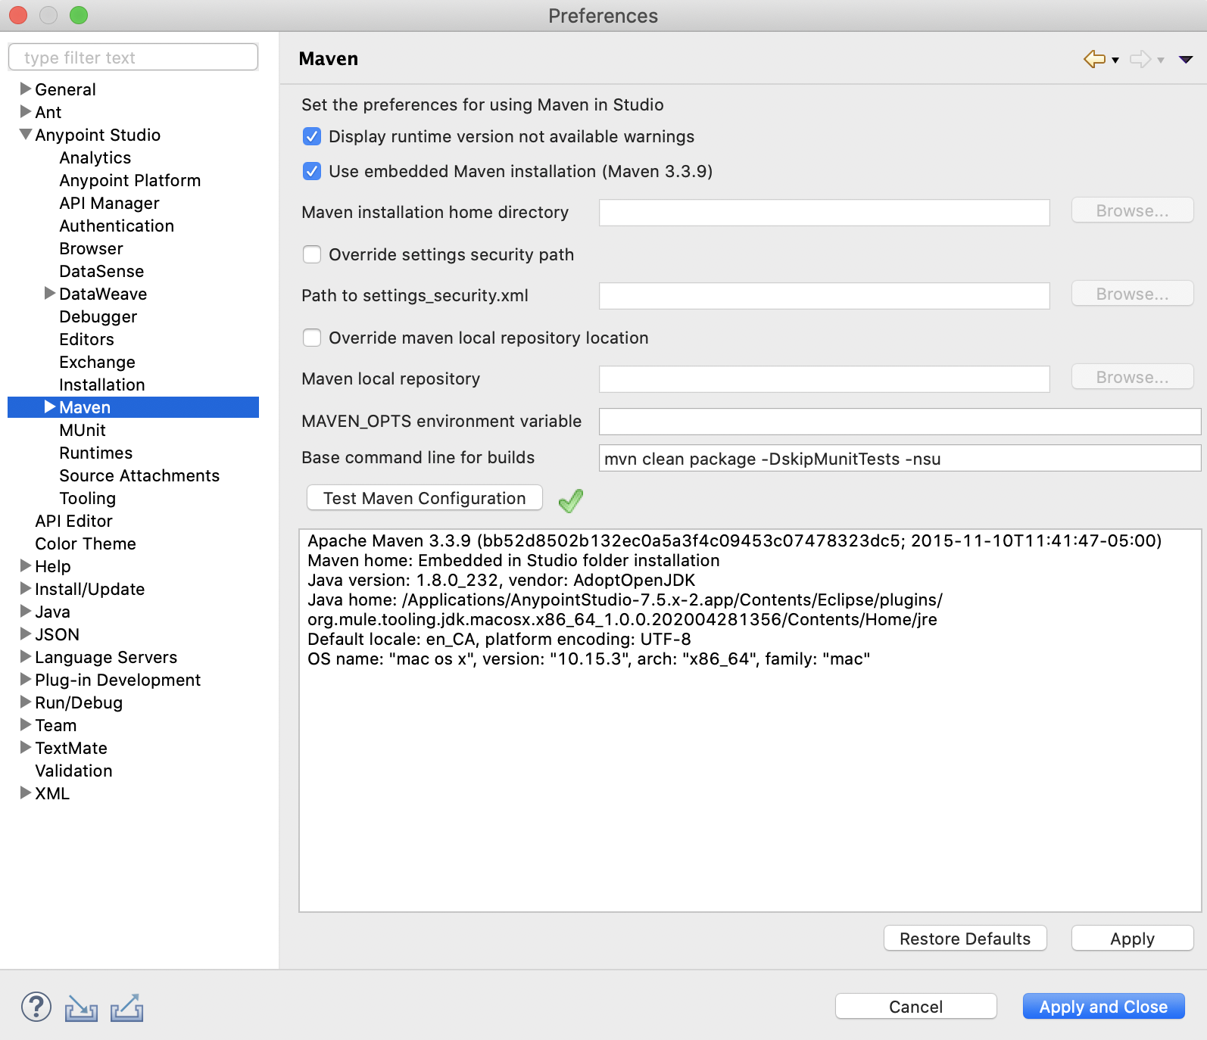

### Configure Anypoint Platform Settings in Studio

During API development and testing, you can download templates from Exchange and synch api artifacts to API designer. In order to support configure the Anypoint Platform login credentials as below.

* 1. Got to Window --> Preferences --> Anypoint Studio --> Authentication. Click “Add” to provide client credentials that will show the below screen.

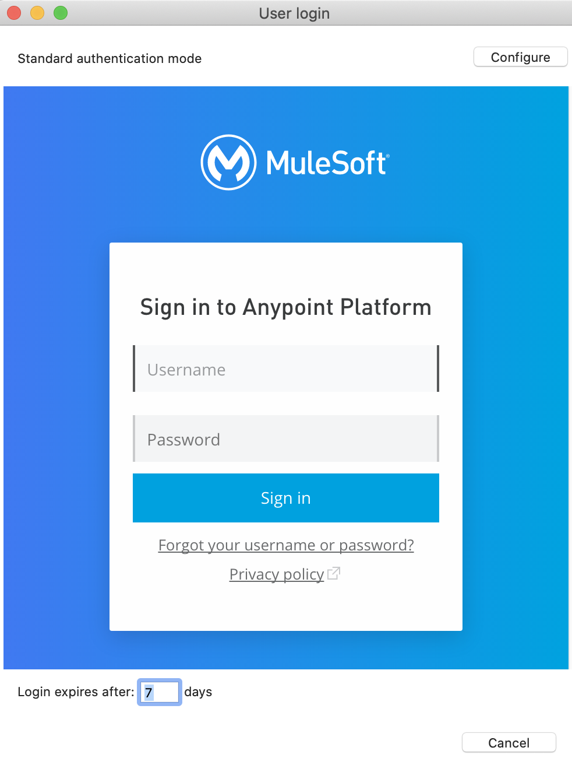

* 1. Enter the “Anypoint Platform” credentials 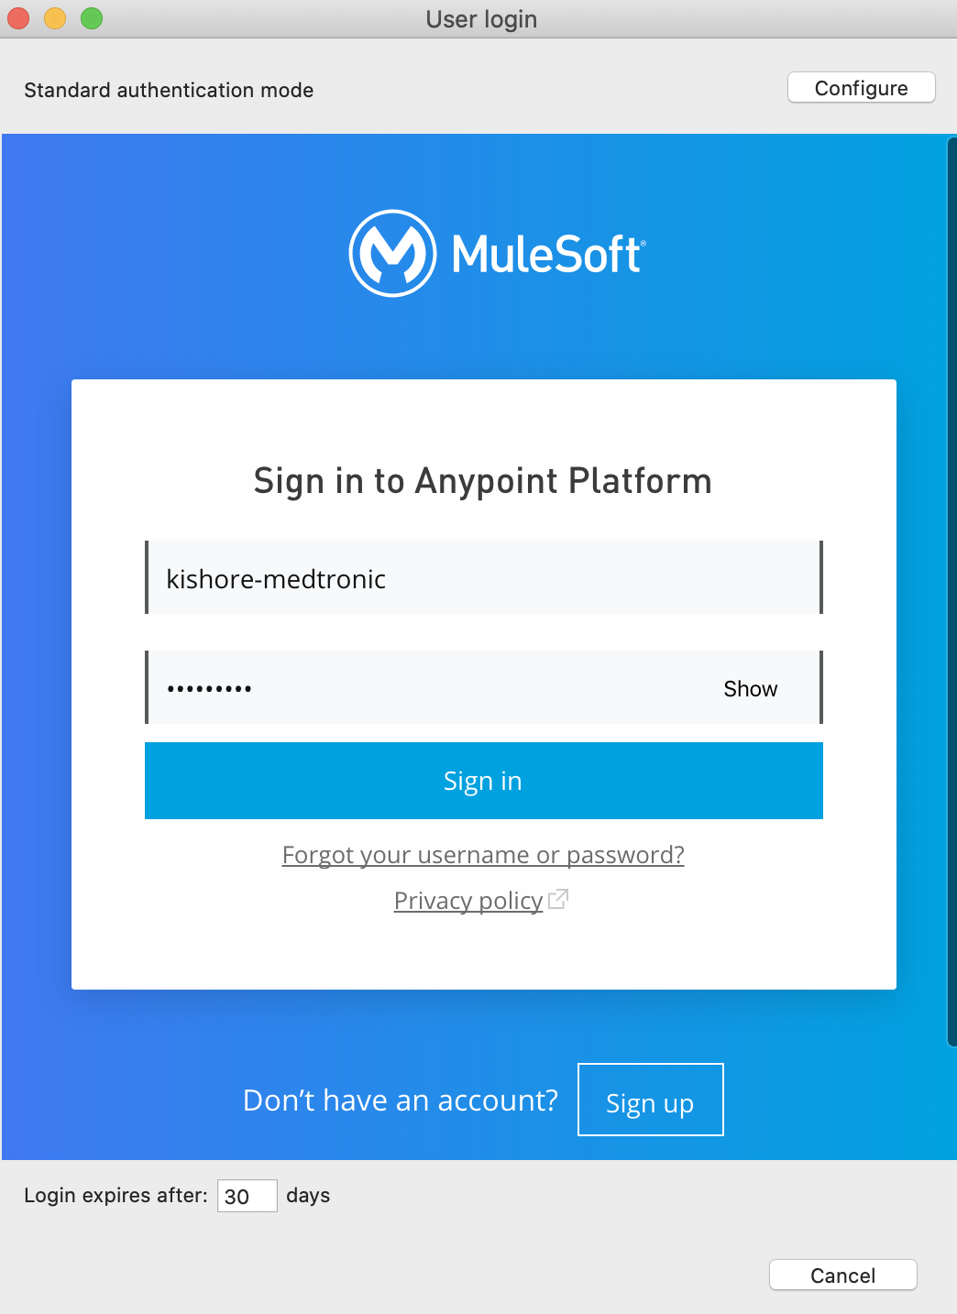

### Maven Settings File

Copy the below contents to C:\${users.home}\.m2\settings.xml folder. Make sure to change the highlighted yellow items with your credentials.

|  |
| --- |
| <settings xmlns="http://maven.apache.org/SETTINGS/1.0.0"  xmlns:xsi="http://www.w3.org/2001/XMLSchema-instance"  xsi:schemaLocation="http://maven.apache.org/SETTINGS/1.0.0  https://maven.apache.org/xsd/settings-1.0.0.xsd">  <localRepository/>  <interactiveMode/>  <usePluginRegistry/>  <offline/>  <pluginGroups>  <pluginGroup>org.mule.tools</pluginGroup>  </pluginGroups>  <servers>  <server>  <!—- Credentials for connecting to MuleSoft Enterprise Nexus -- >  <id>MuleRepository</id>  <username>*****</username>  <password>*****</password>  </server>  <server>  <!—- Anypoint Platform Credentials -- >  <id>Exchange2</id>  <username>*****</username>  <password>*****</password>  </server>  <server>  <!—- Anypoint Platform Credentials -- >  <id>AnypointExchangeRepo</id>  <username>*****</username>  <password>*****</password>  </server>  </servers>  <mirrors/>   <profiles>   <profile>  <id>Mule</id>  <activation>  <activeByDefault>true</activeByDefault>  </activation>  <repositories>  <repository>  <id>MuleRepository</id>  <name>MuleRepository</name>  <url>https://repository.mulesoft.org/nexus-ee/content/repositories/releases-ee/</url>  <layout>default</layout>  <releases>  <enabled>true</enabled>  </releases>  <snapshots>  <enabled>true</enabled>  </snapshots>  </repository>  </repositories>  </profile>   <profile>  <id>mule-extra-repos</id>  <activation>  <activeByDefault>true</activeByDefault>  </activation>  <repositories>  <repository>  <id>mule-public</id>  <url> https://repository.mulesoft.org/nexus/content/repositories/public </url>  </repository>  </repositories>  <pluginRepositories>  <pluginRepository>  <id>mule-public</id>  <url> https://repository.mulesoft.org/nexus/content/repositories/public </url>  </pluginRepository>  </pluginRepositories>  </profile>   </profiles>   <activeProfiles/> </settings> |
|  |
|  |

# Detailed Steps in exposing API in Mulesoft Platform

Following are the general steps to be followed in implementing and publishing APIs using Anypoint Platform.

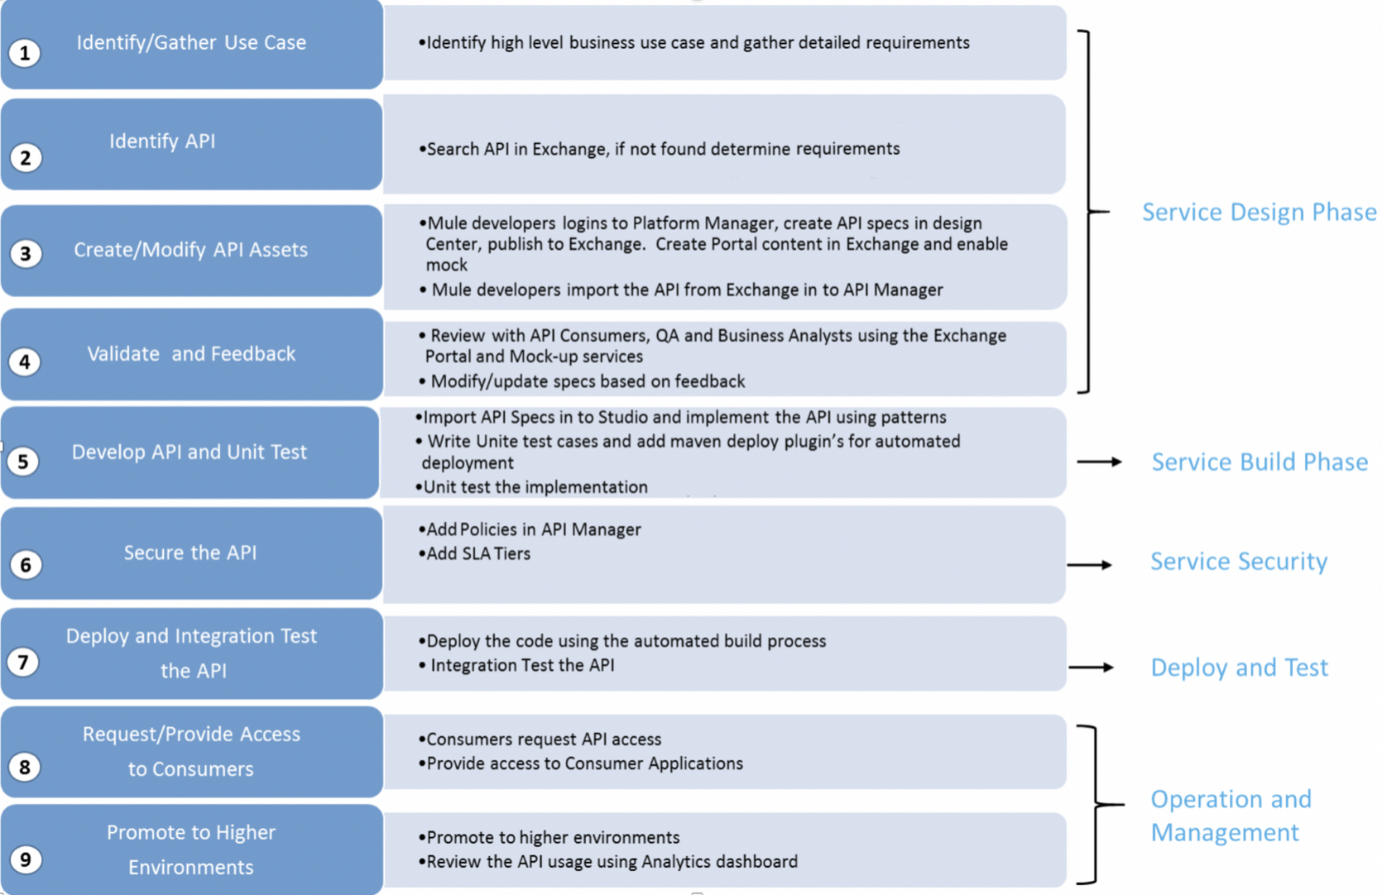

The steps above are numbered and generally follow the order. Details of each step is described in below sections.

## API Design Phase

This phase is concerned with defining and validating the detailed functional and technical aspects of the API. The design process start with identifying and modelling the API resources and relationships among them, identifying the operations to manage the API resources and mapping them to standard HTTP methods, and, finally, definition of the representation format of operations’ request and response messages.

Anypoint Platform for APIs provides capabilities to simulate the API and solicit feedback before exposing the actual backend functionality through the API; this allows the functionality and ease of use of the API to be validated before much effort is invested.

APIs are living software artifacts; they exist over time and will get adjusted and modified during this time. APIs evolve with time, and the design-process needs to take this into account. The design-deliverables (RAML and supplementary documentation) needs to be adjusted as the API is modified and adjusted.

This phase consists of following sub tasks:

|  |  |  |
| --- | --- | --- |
| Process Steps | Tools Used | Roles |
| Identify and understand the business use case. | Sharepoint, MicroSoft Word and any other tools that are used for requirements management | Business Analysts, API Owners, API Developers, API Architects |
| Identify APIs, Resources | Anypoint Exchange | API Owners and API Developers, API Architects |
| Create API Assets | Anypoint Manager: Design Center, Exchange and API Manager | API Owners and API Developers |
| Validate and Feedback | Exchange Portal, Post Man or SOAP UI | API Architects, Business Analysts, QA |

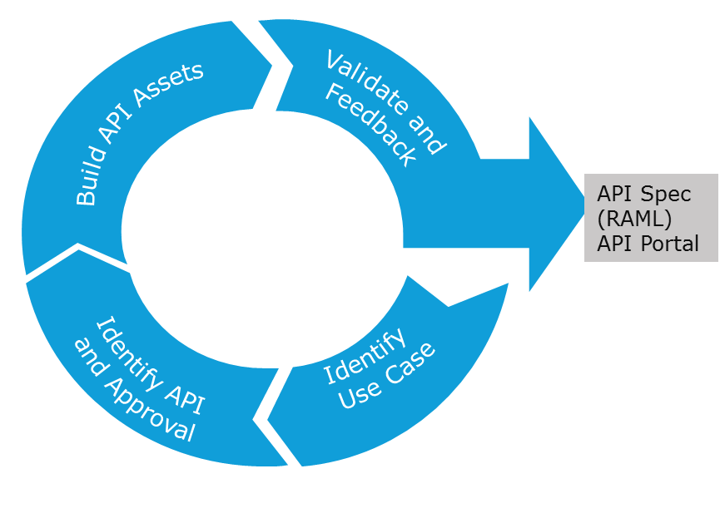

### Identify Use Case (business use-case)

Identify the high-level business functionality which needs to be exposed by the different applications, be referring to use-case documentation from client-applications or requirements-gathering sessions with teams who are requesting the API.

### Identify APIs, Resources

API Owners or Developers first:

1. Search in Anypoint Exchange if an API of similar functionality exists
2. If exists, validate/verify with API Architect to change the existing version by versioning it.
3. If it doesn’t exist, determine the API requirements.
4. Identify the high-level resources based on business-needs.
5. API Owners/Developers/Architect will determine the API category (system, process, experience or proxy) and ownership of the API.

### Create API Assets

API Owners/Developers build the API definition and other assets using Anypoint Design Center and Exchange. Follow the API standards and naming conventions as defined in the document “Medtronic_MuleSoft_Development_Best_Practices.docx”. Following are the API Assets that needs to be developed:

1. RAML Specifications in Design Center.
2. RAML contains the structure of the API signatures, request and response data-schemas, and examples for the API-consumers to use for rapid testing and development with mocks.
3. A well-formed, comprehensive RAML provides developers with a seamless experience - ability to interact directly with the (mocked) API
   * make requests
   * receive request-validation messages - including actual HTTP response-codes applicable to the request made
   * receive responses (with mocked response data)

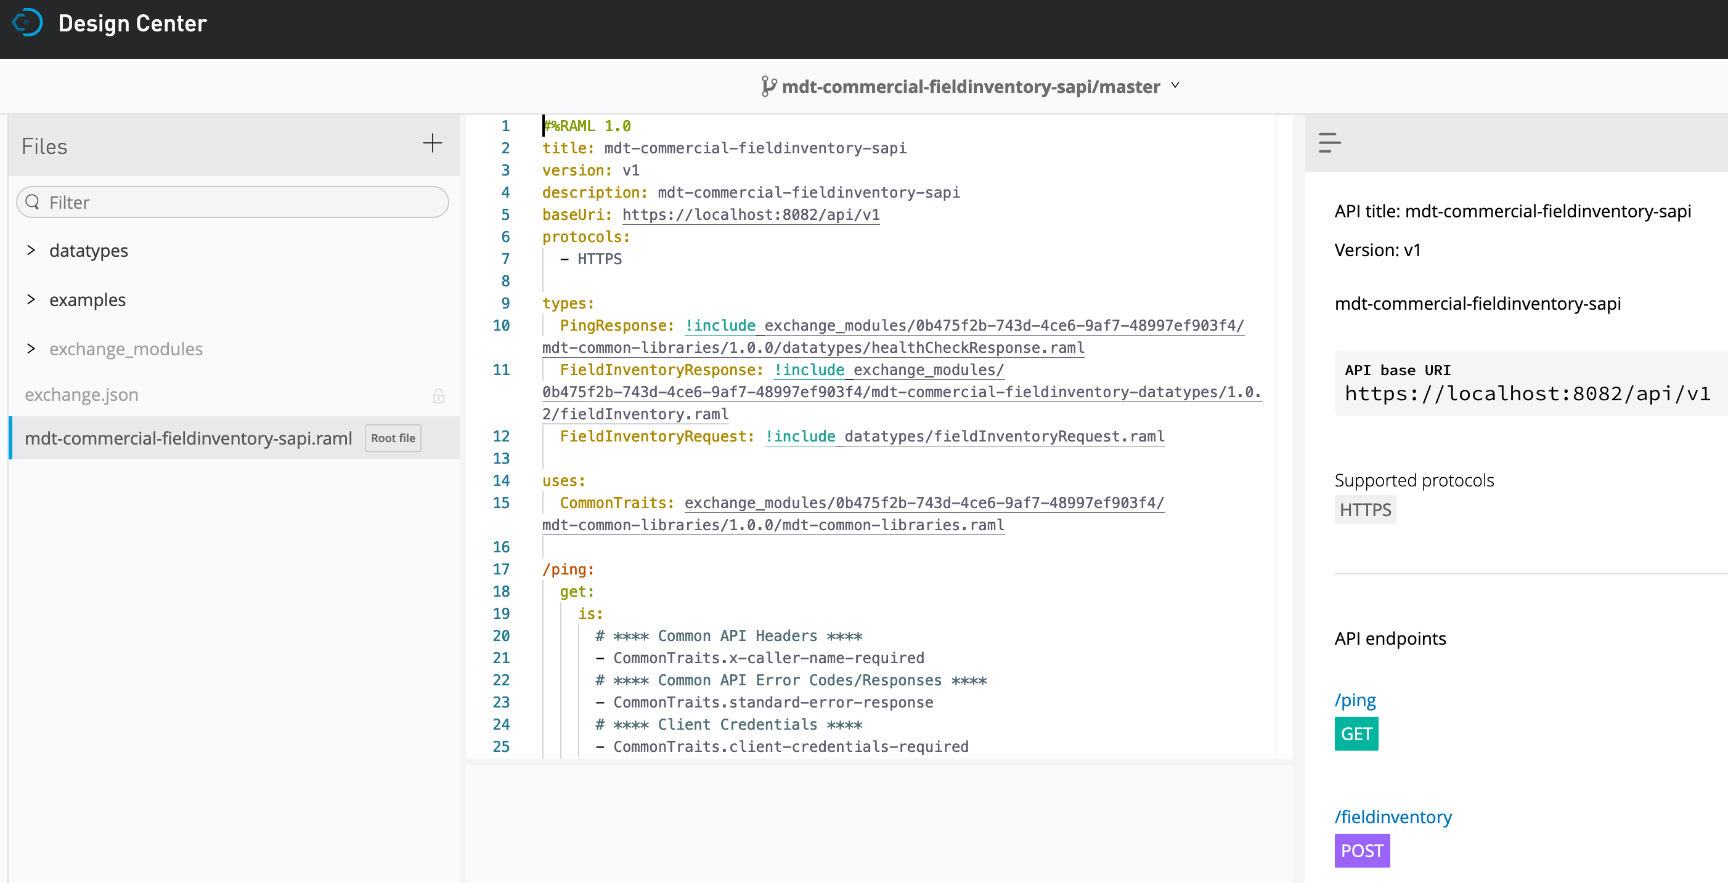

1. Enable Mock-On: Enable the “Mocking Service” in the “Design Center” when creating the Swagger Specifications as this will be used by Application Developers, API Architects, Business Analysts and QA to validate the API before the service is developed. Attached below is an example API designer with RAML specifications and Mocking Service on.

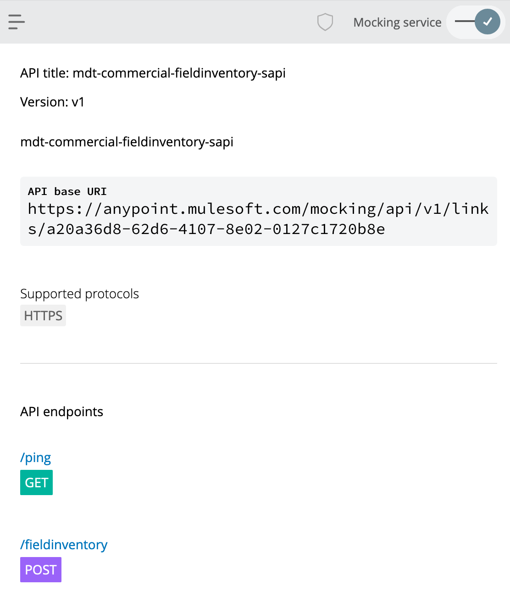

1. Publish the API to Exchange from Design Center.

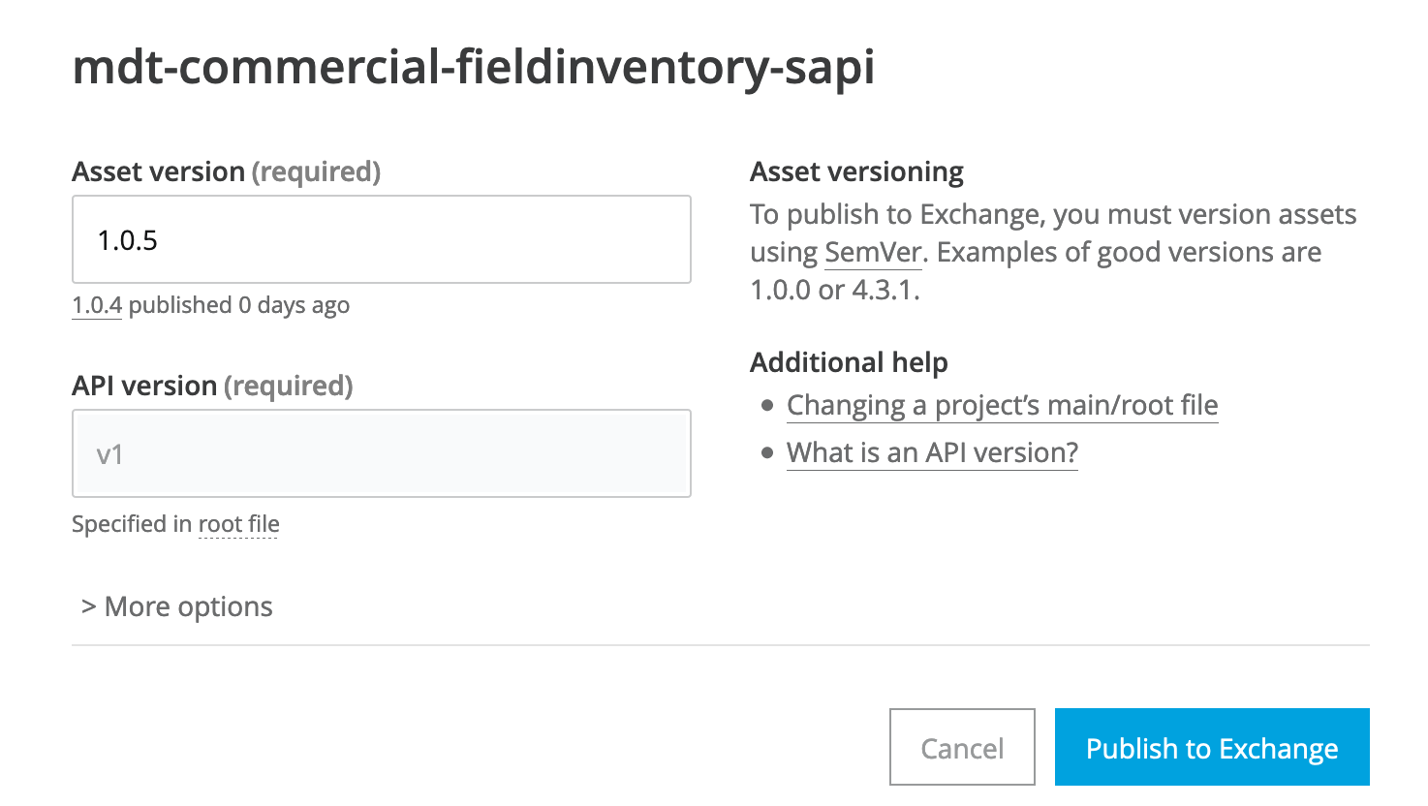

1. Exchange Portal: Exchange Portals allow for the definition of arbitrary content that allow for the better documentation like extensive explanations on how to access the API, methods, diagrams etc of an API.

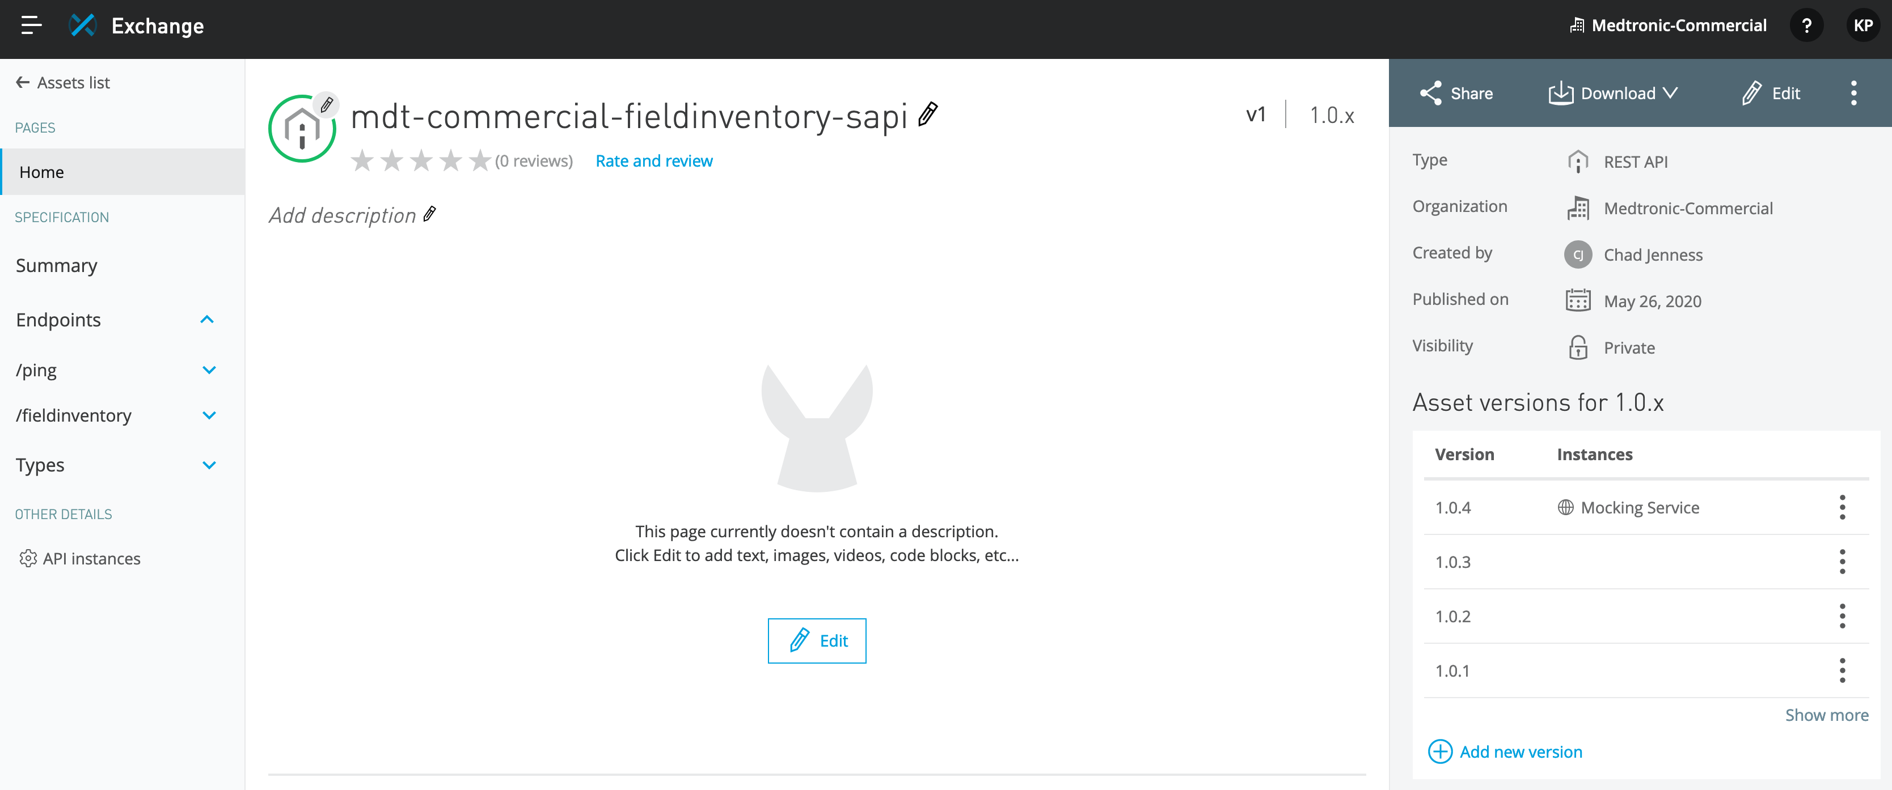

1. Manage in API Manager: Import the API in to API Manager (Development Environment) for managing the API on the API Manager.

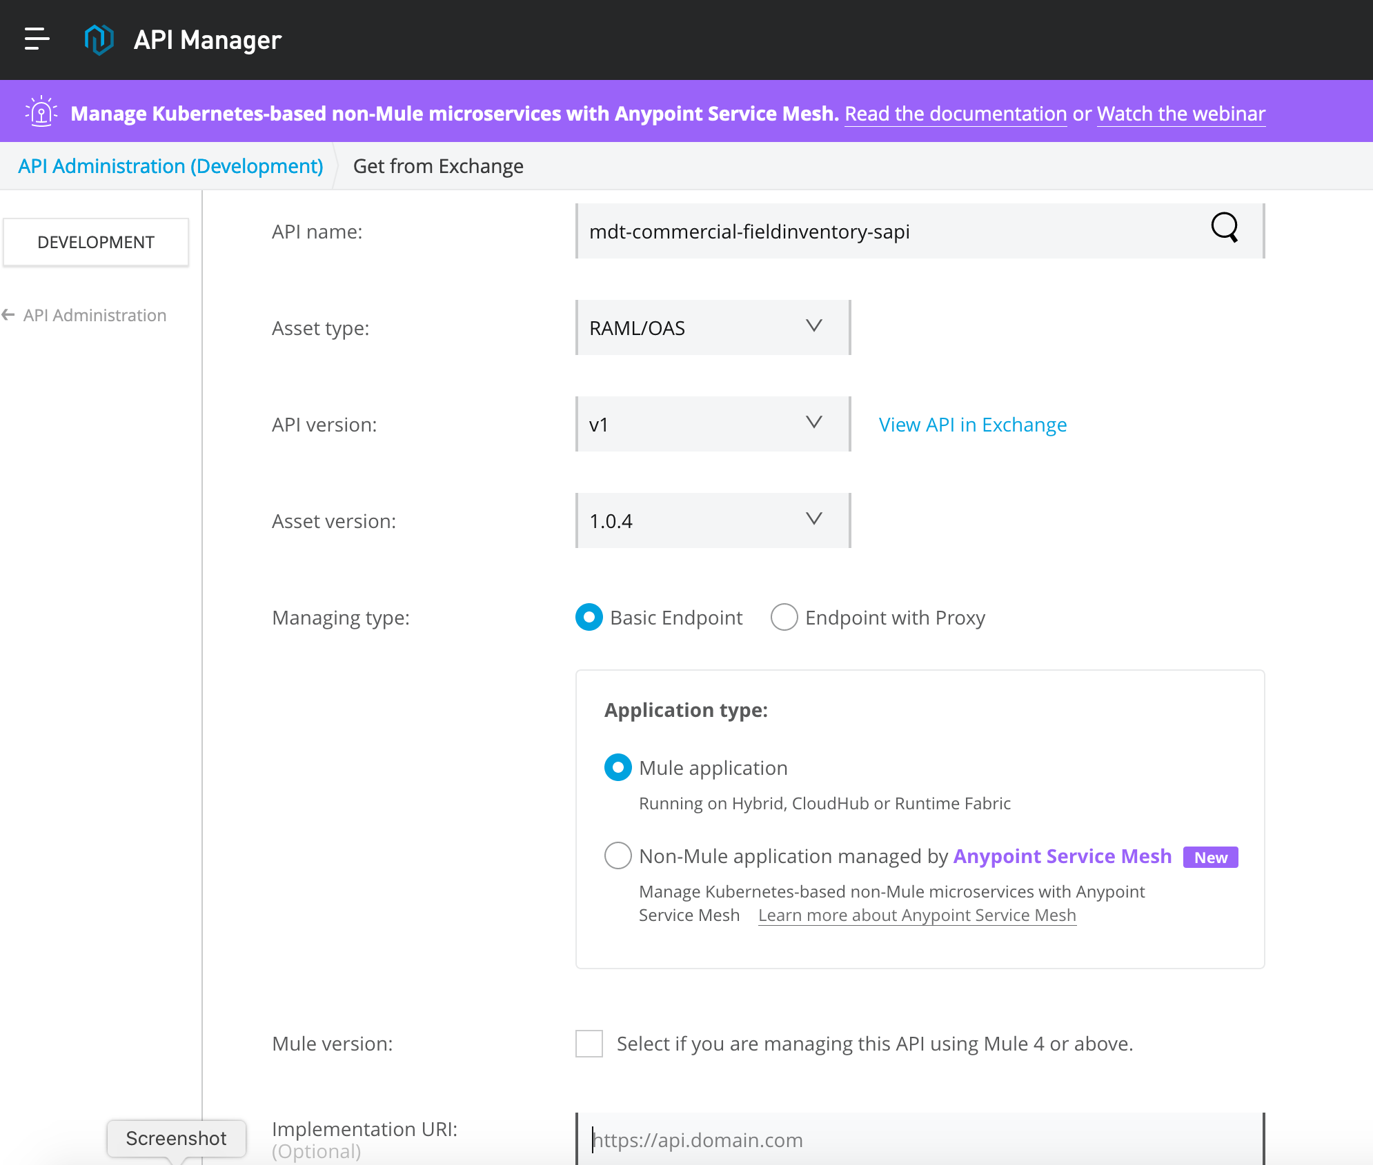

This will generate the API Autodiscovery Id which will be used to link the API Instance with the API Implementation. Update this Autodiscovery Id in the application properties/config file (in the implementation/mule app) to link the API instance with the implementation.

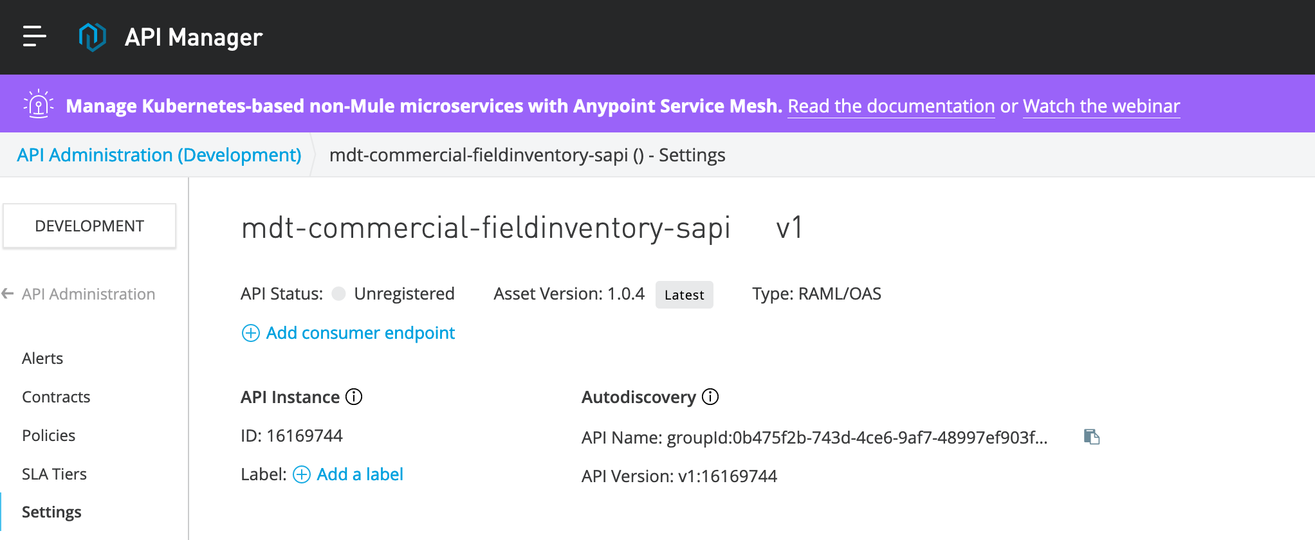

The RAML specification thus developed can be used directly in the development and test phase.

### Validate and Feedback

Once the API is defined and Exchange portal is published, publish/email the Exchange portal link to Business Analysts, API Architects, Application Developers and QA team for review and validating the API. The team can use the API developer portal to test various scenarios, validate the expected request and response structure and the business needs. The team can provide the feedback through API developer portal itself.

## API/Service Build Phase

Following the API design phase, the build and test phase translates the defined API definition of the design phase into well-tested, implementation artifacts. Follow the Mule design and coding guidelines published in sharepoint.

Once API designed, the API needs to be built by connecting to the backend services or applications that will power it.

MuleSoft’s Anypoint APIKit and associated tooling makes creation of well-designed REST APIs a quick and efficient process. Importing a Swagger file allows automatic generation of the following items (screen shot below):

* A main flow with an HTTP endpoint, an APIkit Router, and an Exception Strategy reference
* Skeletal back-end flows, one for each resource/HTTP-verb pairing in the RAML file
* Several Global Exception Strategy mappings
* The default Global Exception Strategy will eventually be replaced with the exception handlers defined in the Medtronic API Template.

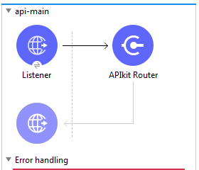 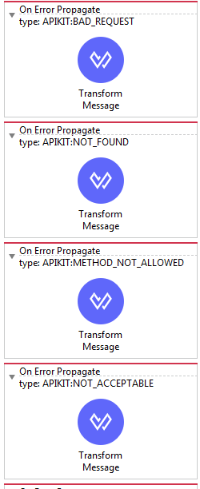

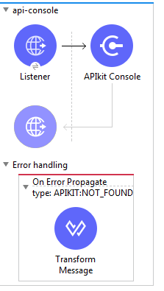

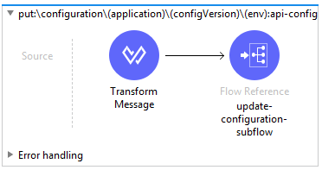

The developers can use the prebuilt reusable artifacts like templates, libraries and connectors to accelearate application development. The details of the prebuilt reusable artifacts are given below.

1. **Medtronic API Template**

The Medtronic API Template includes the foundation/building blocks required for the API/Integration project development. It includes the common artifacts like Error Handler Plugin, Logger Plugin, Common Properties files (secured/non-secured), HTTP(S) connections, Logging & Exception Handling.

Medtronic API Template can be found on the Anypoint Platform at the below URL.

<https://anypoint.mulesoft.com/exchange/0b475f2b-743d-4ce6-9af7-48997ef903f4/mdt-api-template/>

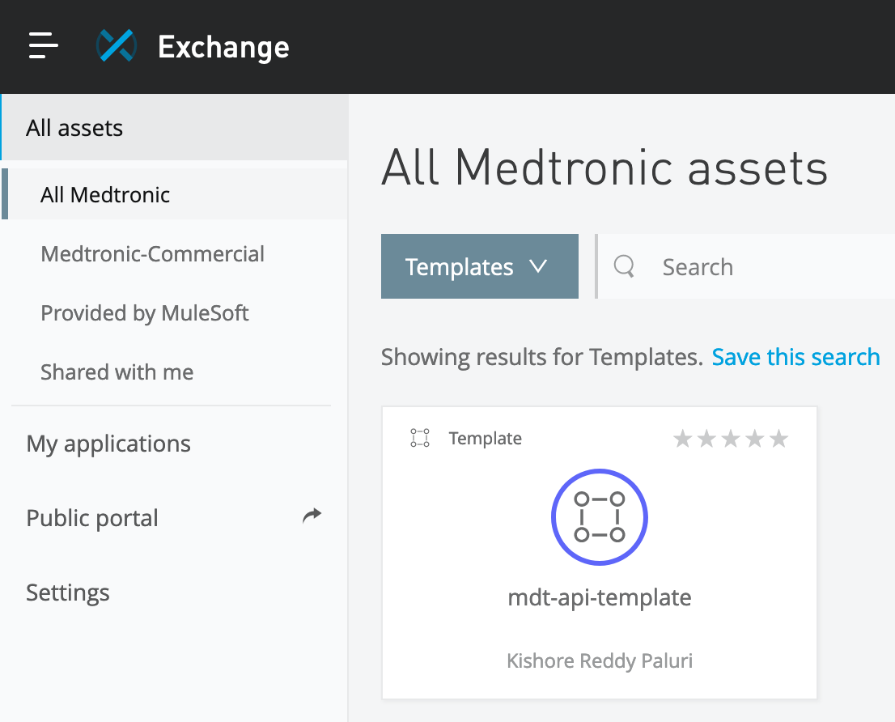

Usage related details has been published on the Anypoint Exange and please refer to the above mentioned URL for more details.

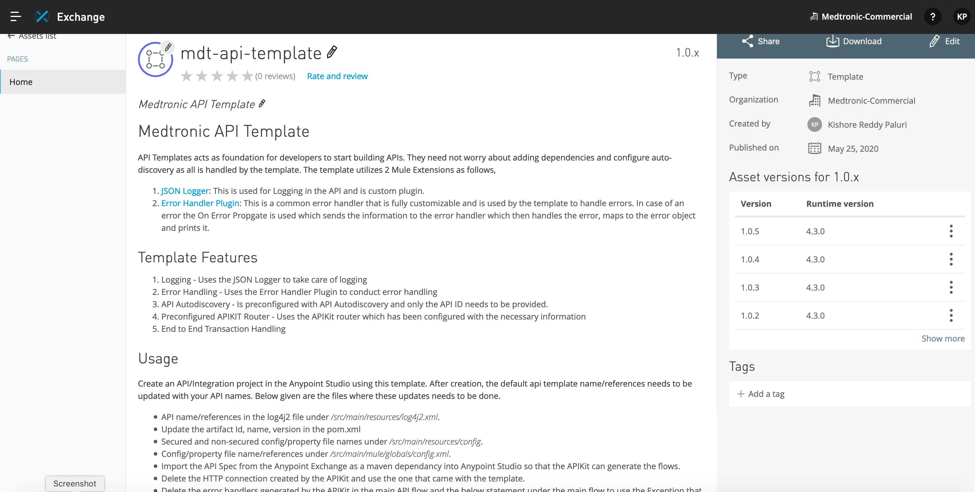

The source code for this template has been published to Medtronic BitBucket.

[<<TBD>>](http://oxysvwpsf01:7990/projects/MUL/repos/alterna-api-template/browse)

1. **Error Handler Plugin**

This custom error handler is capable of handling various error scenarios. It allows a single module to process error messages from multiple types:

* Error types default to mule. (HTTP, APIKIT, Connectors based, etc)
* custom error types as defined by raise error component.
* Un-clutter exceptions both in UI and XML
* User can change the custom error message (for multiple errors) in the UI rather than in the XML.
* No specific error type is required for this module. It can parse any error types.

The Error Handler Plugin can be found on the Anypoint Platform at the below URL.

<https://anypoint.mulesoft.com/exchange/0b475f2b-743d-4ce6-9af7-48997ef903f4/error-handler-plugin/>

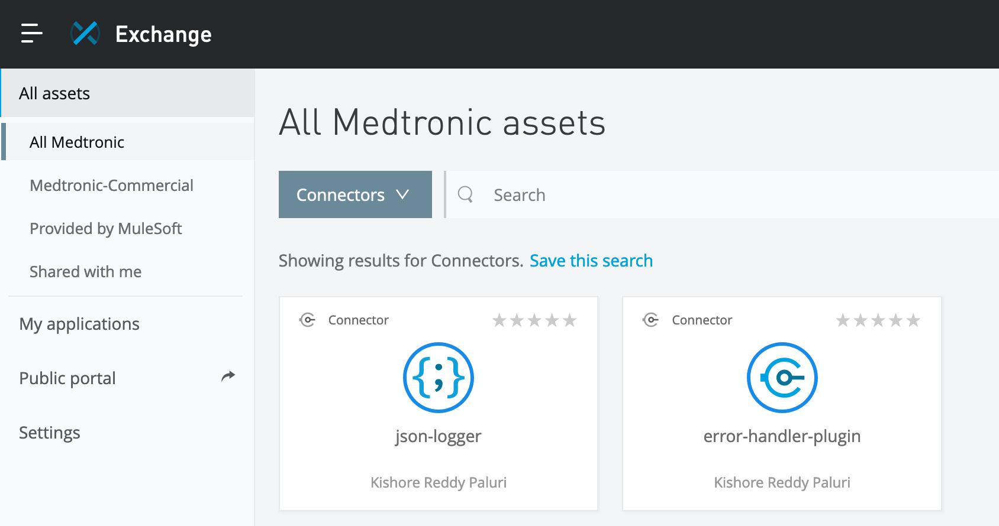

Usage related details has been published on the Anypoint Exange and please refer to the above mentioned URL or more details.

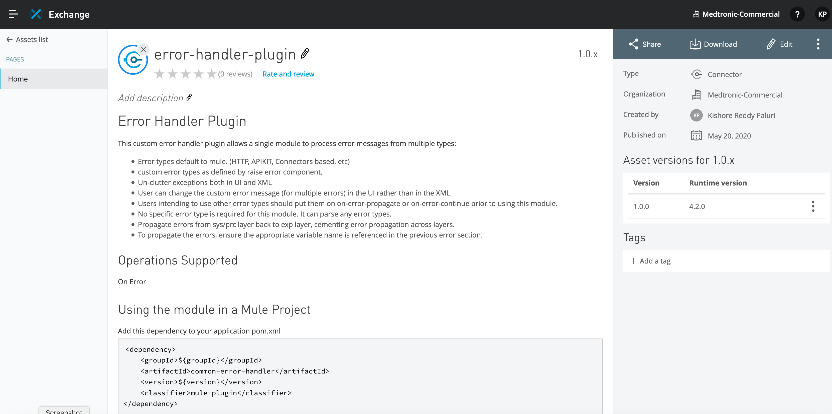

The source code for this template has been published to Medtronic GitHub.

[<<TBD>>](http://oxysvwpsf01:7990/projects/MUL/repos/error-handler-plugin/browse)

1. **JSON Logger Plugin**

This custom JSON Logger can be used to output the logs in JSON format for consistent logging experience and these logs can be easily digested by any Enterprise logging tools.

The JSON Logger Plugin can be found on the Anypoint Platform at the below URL.

<https://anypoint.mulesoft.com/exchange/0b475f2b-743d-4ce6-9af7-48997ef903f4/json-logger/>



Usage related details has been published on the Anypoint Exange and please refer to the above mentioned URL or more details.

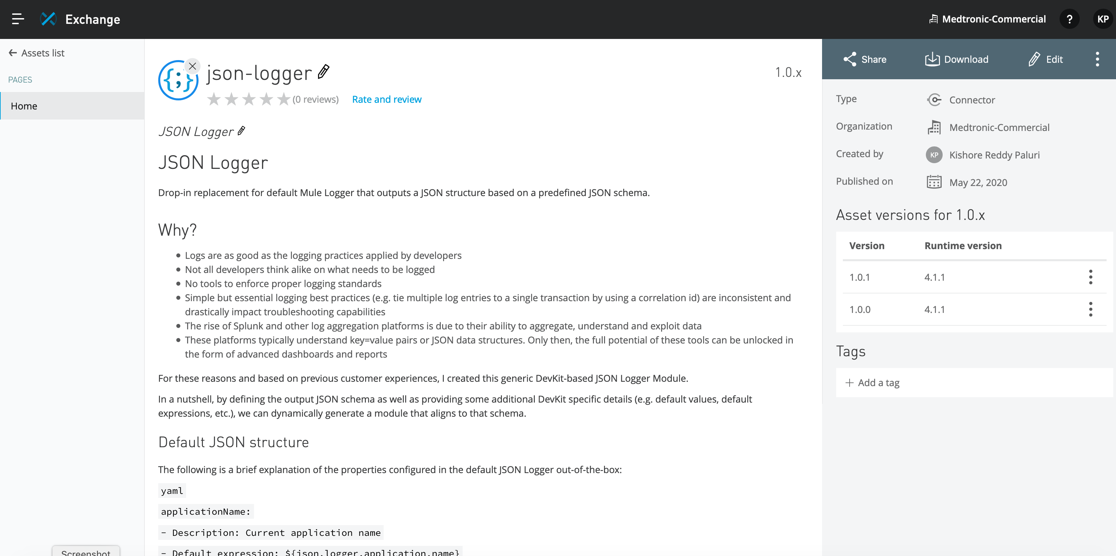

The source code for this template has been published to Medtronic GitHub.

[<<TBD>>](http://oxysvwpsf01:7990/projects/MUL/repos/json-logger/browse)

The build phase consists of two main tasks: build and test that will produce a service with API as shown below:

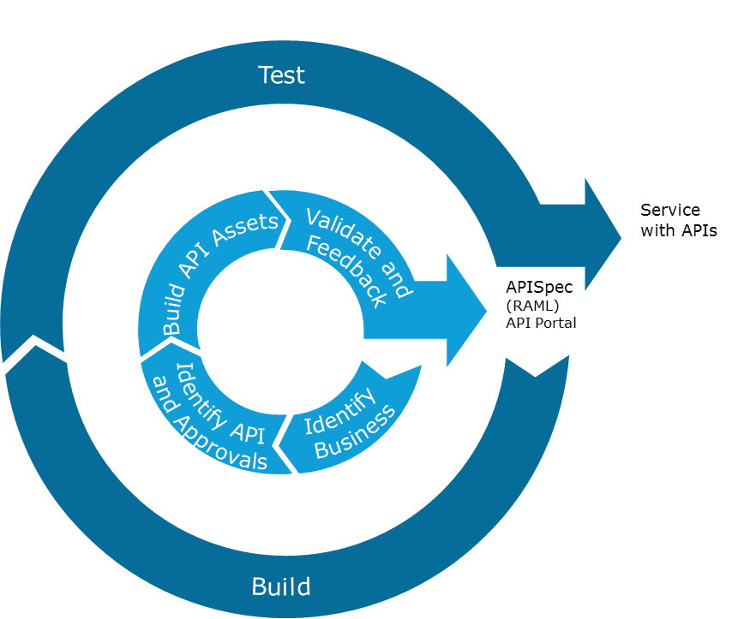

|  |  |  |
| --- | --- | --- |
| Process Steps | Tools Used | Roles |
| Develop API using the API Specs | Anypoint Studio, Postman or SOAP UI, Anypoint Exchange | API Developers |
| Test the Service | Anypoint Studio, MUnit, Postman or SOAP UI | API Developers |

### Develop API/Service using the API Specs:

The Mule software components required for development are listed in the Section 2 “***Developer Environment Setup***”. API Developers follow the development best practices defined in the “***Medtronic_MuleSoft_Development_Best_Practices.docx***”. Below given are the detailed steps to be followed for build/development:

1. Developers launch Anypoint Studio.
2. Create New Mule Project using the Medtronic API Template (by importing the jar from Exchange)
   1. Enter Project Name (as per the naming conventions recommended in the ***“Medtronic_MuleSoft_Development_Best_Practices.docx”***)
   2. Right click on the project, click on the properties to navigate to the

Mule Project -> APIs

In order to import the RAML from Anypoint Exchange.

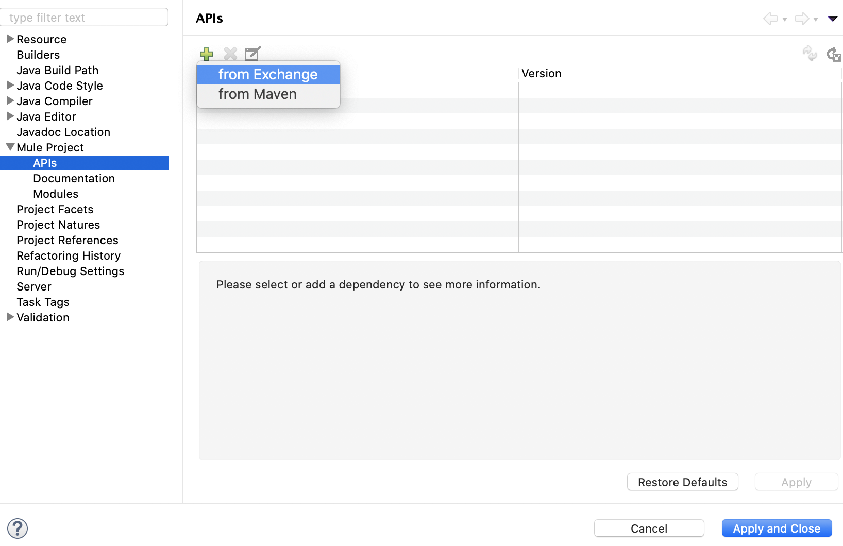

* 1. Click Finish

1. Update artifact Id/name/version in pom.xml
2. Once the RAML is imported from the Exchange, skeleton flows are created automatically.
3. Delete the error handlers generated by the APIKit in the main API flow and the below statement under the main flow to use the Exception that came with the template.

|  |
| --- |
| <error-handler ref=*"ApiKit_Error_Handler"* /> |

1. Implement the code/logic as per the requirement.
2. Write MUnit test cases for all flows within the API, MUnit should have mocks for external integrations. More details on the Testing described in section below.
3. Deploy and test in runtime embedded in Anypoint Studio.
4. Check-in the code to Medtronic repository.

### MUnit Testing

TBD

# Secure the API

TBD

# Automated Deployment

TBD